$$statistics-session-3$$

$$I will share two text books in statistics$$

$$Open intro Statistics$$

$$ken black$$

$$Prof.Leonard$$

$$khan academy$$

$$algebra math :Matrix eigen eigen$$

$$stanford: Andrew NG ( Math)$$

$$6 ai agents===$$

$What is statistics$

$Inferential statistics$

$Population and sample$

$Data types$

$Categorical and Numerical$

$Nominal,ordinal$

$Interval,Ratio$

$Frequency table$

$Bar chart$

$Relative frequency table$

$Pie chart$

$Frequeny distribution table$

$Histogram$

$Distribution plots$

$$Distribution of data$$

$$In order to understand the data more$$

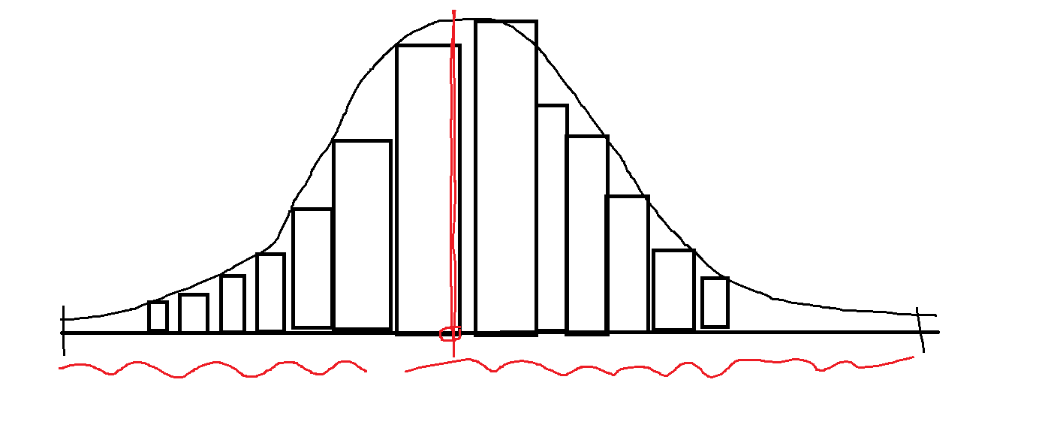

$data center point analysis (Central tendency)$

$mean$

$Median$

$Mode$

$Data flow analysis or Data dispersion$

$Range$

$Mean deviation$

$Absolute mean deviation$

$Variance$

$Standard deviation$

$$Mean$$

$$example:VK average 50 in ODI$$

$$if we give bat to VK , we can expect 50 runs$$

$$Average: \frac{sum of total observations}{Number of observation}$$

$$Virat kohli average in ODI is 50$$

$$if VK goes to the ground every time we can expect that he can score 50 runs$$

$$SSC = 6 subjects Telugu Hindi English Maths Sci Soca$$

$$Avg=μ= \frac{{(x}_{1}+ x_{2}+x_{3}+x_{4}+x_{5}+x_{6})}{6}=\frac{91+ 81+92+89+90+94)}{6}=89.5$$

$$\overline{x} =for sample mean$$

$$For 1,2,3,4,…. N observations$$

$$population mean= \frac{{(x}_{1}+ x_{2}+x_{3}+….+x_{N})}{N}$$

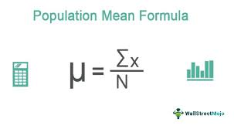



$$\frac{{(x}_{1}+ x_{2}+x_{3}+x_{4}+x_{5}+x_{6})}{6}=\frac{1}{6}*\sum_{i=1}^{6}{x_{i}}$$

$$Average=\frac{{(x}_{1}+ x_{2}+x_{3}+….+x_{N})}{N}=\frac{1}{N}*\sum_{i=1}^{N}{x_{i}}=Middile value$$

$$Median$$

$$Median is also a middile value$$

$$1,5,20,21,16,17,3====what is the middile value$$

$$Make numbers in ascending or descending order$$

$$1, 3, 5, 16, 17, 20, 21 \left(Middile point=16\right) odd numbers$$

$always paste raw data on real axis either ascending or descending order$

$$1,5,20,21,16,17,3,7$$

$$1, 3, 5, 7, 16, 17, 20, 21 : Middile point=\frac{7+16}{2}=\frac{23}{2}=11.5$$

$$Median=50 Percentile of data$$

$$Mean vs Median$$

$$Median is better$$

$$why Median$$

$$Example:$$

$$Case-1: Assume that indian income ppl$$

$x_{1}=50k x_{2}=75k x_{3}=1l x_{4}=2l$

$$Mean: 1.06lakhs Median : 87.5k$$

$$Case-2: Assume that indian income ppl$$

$x_{1}=50k x_{2}=75k x_{3}=1l x_{4}=2l , x_{5}=1000crs$

$$Mean: 200crs Median : 1lakh$$

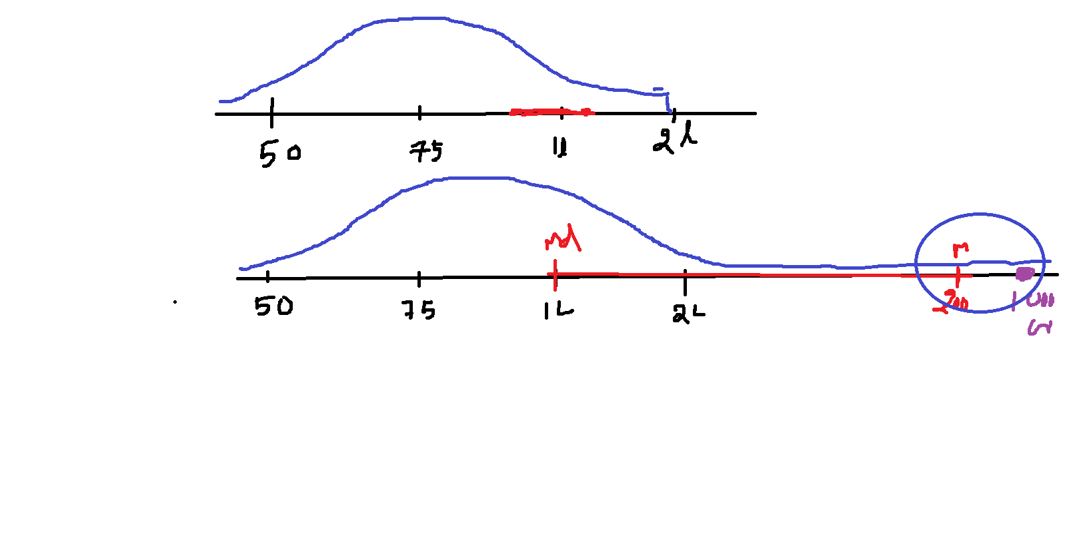

$$whenever in the data very very huge obervation or very very low observations$$

$$consider as outlier$$

$$whenever data has outlier Mean will affect , median doesnot affect$$

$$How to find outlier observations$$

$$How to deal the outliers$$

$$Mode:$$

$$Highest peak in a distribution plot$$

$$Most repated observation$$

$$1,1,1,2,2,2,2,2,3,3,3,3,3,3,3,4,5,5,5,5====Mode=3$$

0.5 to 1 3

1 to 1.5 0

1.5 to 2 5

2 to 2.5 0

2.5 to 3 7

3 to 3.5 0

3.5 to 4 1

4 to 4.5 0

4.5 to 5 4

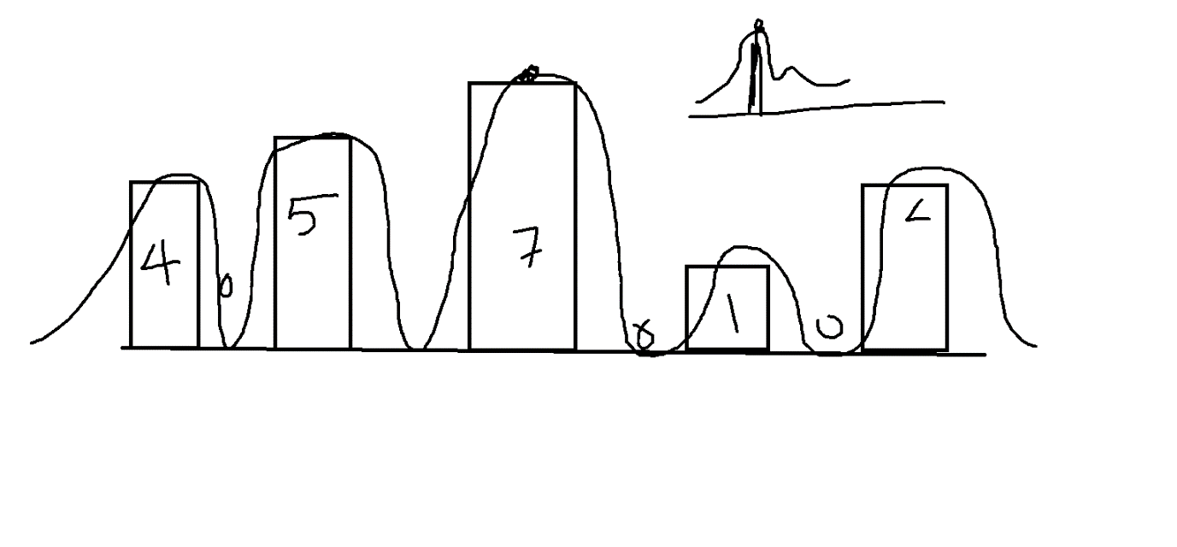

In the data distribution the highest peak is Mode but it is not a number

It is the count of the interval

Which means in that interval most observation are falling

$$Summary:$$

$$Mean Median mode all will use to Identify Middile point only$$

$$Mean affect by Outlier:$$

$if we have a postive outlier mean will go to the postive side$

$if we have a negative outlier mean will go the negative side$

$$Median does not affect by outlier$$

$$Median also called 50P data$$

$$Mode is highest peak in data distribution$$

$If a distribution has single peak:Unimode$

$If a distribution has two peaks:Bi-mode$

$If a distribution has multiple peaks:Multi-mode$

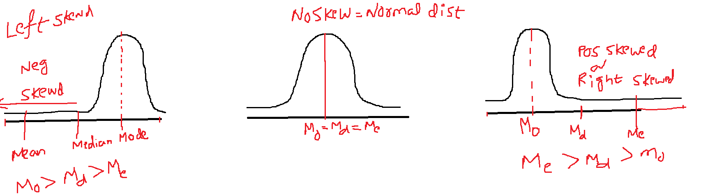

$$Left skewed or Negative Skewed:$$

$Because of Negative outliers$

$Mode>Median>Mean$

$$Right skewed or Postive Skewed:$$

$Because of Postive outliers$

$Mode<Median<Mean$

$$No skew or Normal distribution:$$

$No outliers$

$Mode=Median=Mean$

$Bell shape curve$

$50\% data in left side and 50\% in Right side$

$$Raw===CI====CIF===Histogram====Distribution====skewed or Not$$

$$Kurtosis:will explain about skewness (Assignment)$$